Vector Image

📘 Definition
# Source: AI Source: Provided by: [Data Path: Persons Table -> ID Column: 1, Name_En Column: Motasem Essam] -> From: [ChatGPT] on [5/2/2026]
A Vector Image is an image made using mathematical shapes like points, lines, curves, and polygons, instead of pixels.
It can be resized to any size without losing quality.

📐 How vector images work
# Source: AI Source: Provided by: [Data Path: Persons Table -> ID Column: 1, Name_En Column: Motasem Essam] -> From: [ChatGPT] on [5/2/2026]
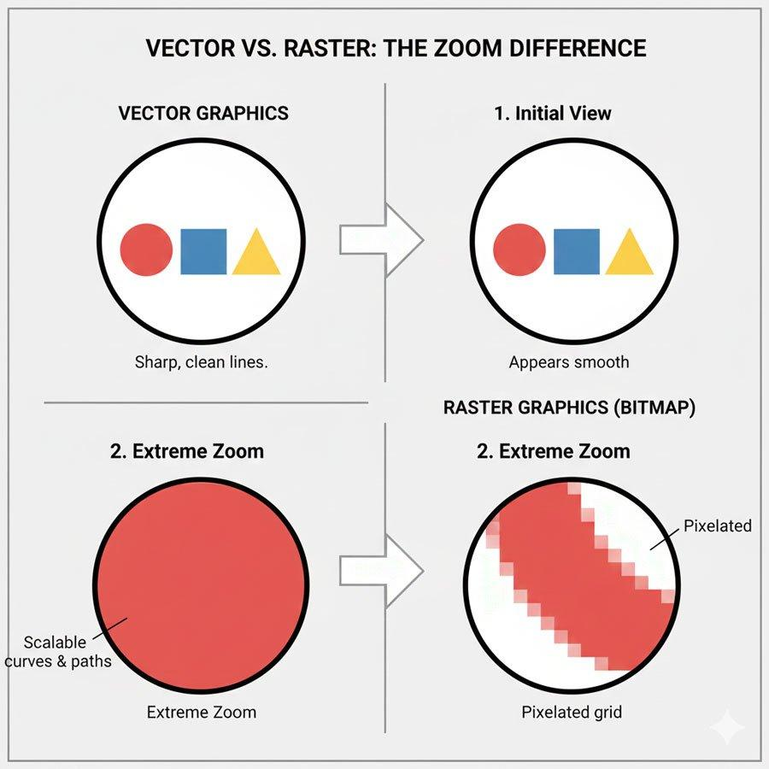
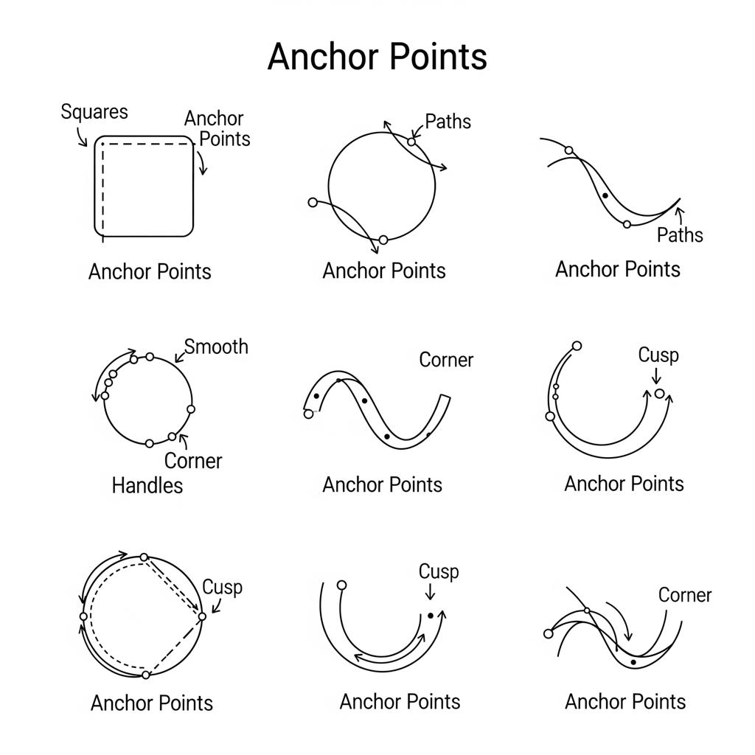
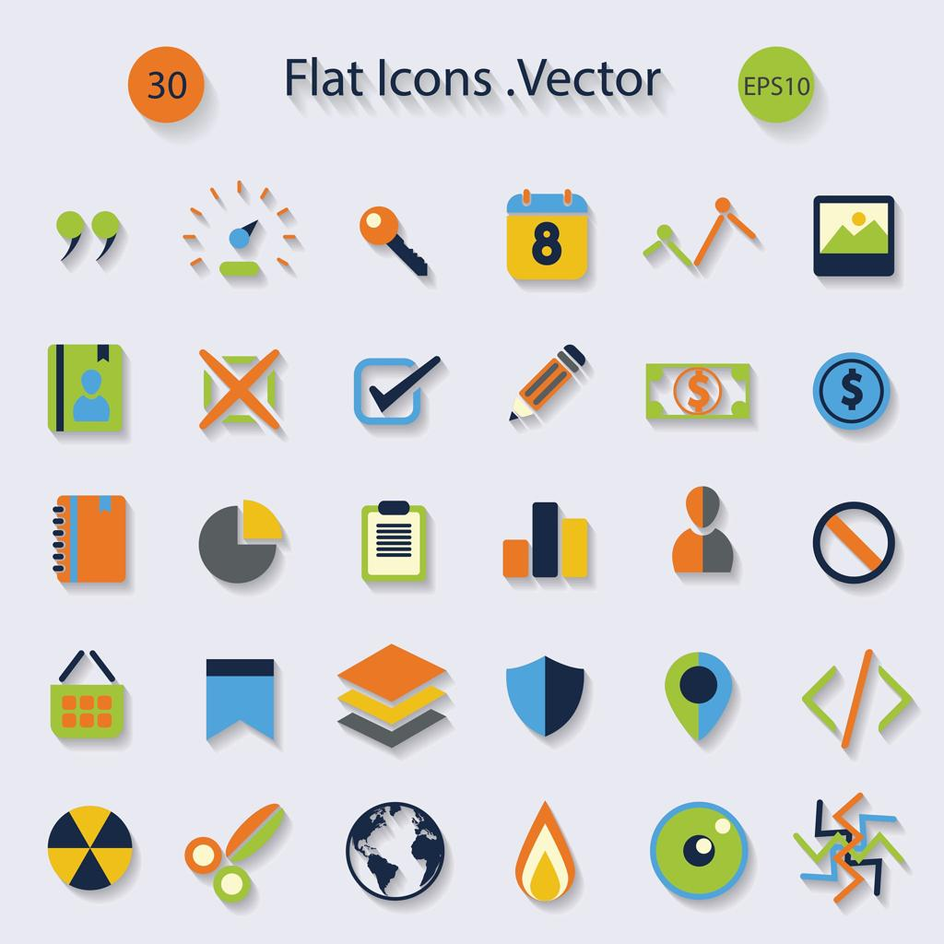
- Created using mathematical formulas
- Built from paths (lines and curves)
- Stored as instructions, not pixels
- Image is redrawn every time it is displayed

🧠 Simple example
# Source: AI Source: Provided by: [Data Path: Persons Table -> ID Column: 1, Name_En Column: Motasem Essam] -> From: [ChatGPT] on [5/2/2026]
Think of:
- 🖋️ A logo (like a company icon)
- 🔺 Simple illustrations or cartoons
- 📊 Icons on apps or websites
If you zoom in, it stays sharp and clear.

🎮 Where vector images are used
# Source: AI Source: Provided by: [Data Path: Persons Table -> ID Column: 1, Name_En Column: Motasem Essam] -> From: [ChatGPT] on [5/2/2026]
- 🎨 Logos and branding
- 🌐 Website icons and UI design
- 🧑‍💻 App and interface graphics
- 🖨️ Printing (posters, banners)

⚙️ Key features
# Source: AI Source: Provided by: [Data Path: Persons Table -> ID Column: 1, Name_En Column: Motasem Essam] -> From: [ChatGPT] on [5/2/2026]
- 📐 Made from math-based shapes
- 🔍 No loss of quality when zoomed
- 🧩 Lightweight file size
- 🎨 Easy to edit and resize

🚀 In short:
# Source: AI Source: Provided by: [Data Path: Persons Table -> ID Column: 1, Name_En Column: Motasem Essam] -> From: [ChatGPT] on [5/2/2026]
Vector Image = an image made from mathematical shapes that stays sharp at any size without becoming blurry.

